INTERNSHIP REPORT
on
Drone Swarm Navigation Using SMA with Stigmergy

Submitted by

GIRIJAN D
(Reg. No: 2117240030033)
TEJASWINI P N
(Reg. No: 2117240070327)
VARNA OVIYA V
(Reg. No: 2117240070337)
VARSHANI S V
(Reg. No: 2117240070338)
VARUSHA A
(Reg. No: 2117240070340)

B.E. – Artificial Intelligence and Machine Learning
B.Tech. – Artificial Intelligence and Data Science
Rajalakshmi Institute of Technology

Submitted to
National Institute of Technical Teachers Training and Research (NITTTR)
Chennai – 600113

Internship Duration: 10th June 2026 to 10th July 2026

Under the guidance of
Dr. Balasubramanian Esakki
Professor, Mechanical Engineering
National Institute of Technical Teachers Training and Research (NITTTR) Chennai - 600113

1. Abstract:
The problem of coordinating a swarm of Unmanned Aerial Vehicle (UAVs) in an environment with communication limitations is crucial in the field of autonomous systems. This report suggests a novel hybrid algorithm that integrates the Slime Mould Algorithm (SMA) and the stigmergy based indirect coordination for multi-drone navigation. The idea is to combine SMA's adaptive oscillation mechanism (which determines the ratio of exploration/exploitation using rank-based weights) with a distributed pheromone field that is a physical signal accessible locally, without requiring radio communication. Each drone is equipped with an algorithm that replaces the global best reference position with its own self-reference; navigation is also performed using a shared pheromone field, which is deposited, evaporated, and diffused with Gaussian distribution continuously between drones. The algorithm is tested in a Software-In-The-Loop simulation environment using PX4 SITL, Gazebo Harmonic and QGroundControl, and MAVSDK also allows the algorithm to be controlled programatically while offboarding. Experimental results show that the swarm convergence performance is not degraded by any conditions, thus, establishing pheromone-based environment memory as a viable approach for resilient autonomous swarm navigation, as a backup to the global best dependent algorithms in scenarios that degrade drastically.

2.Introduction:
Unmanned Aerial Vehicles (UAVs) are increasingly used in military, industrial, and civilian applications, driving research into autonomous multi-drone swarm systems. Traditional swarm coordination methods, such as Particle Swarm Optimization (PSO) and formation control, rely on continuous communication to share global information. However, in GPS-denied environments, communication failures significantly reduce their effectiveness. Inspired by biological systems, this Report proposes a hybrid coordination algorithm combining the Slime Mould Algorithm (SMA) with stigmergy-based pheromone fields. SMA provides adaptive exploration and exploitation through dynamic position updates, while the pheromone field enables indirect coordination using locally sensed environmental cues instead of direct communication. Each drone deposits virtual pheromones based on fitness, allowing robust navigation even when communication is disrupted. The algorithm is validated in a high-fidelity Software-in-the-Loop (SITL) environment using PX4, Gazebo Harmonic, QGroundControl, and MAVSDK Python, demonstrating resilient and scalable swarm navigation under both normal and communication-denied conditions.

2.1 Problem Statement
How can a UAV swarm navigate effectively and converge toward a mission target in a 3D environment while avoiding obstacles, maintaining coordination across multiple agents, and operating resiliently even when individual agents lose access to the swarm's global best reference?

2.2 Proposed Solution
A hybrid SMA + Stigmergy algorithm where drones coordinate via a shared 3D pheromone field that acts as a persistent environmental memory layer. As drones move through the search space, they deposit pheromone proportional to the quality of their current position. Other drones sense this gradient and bias their movement accordingly

3. System Architecture

Item | Detail
Python Algorithm Script | Runs the SMA+Stigmergy algorithm each iteration, computes new target positions for every drone, and sends those commands down through MAVSDK
MAVSDK (Python Library) | Translates Python position commands into MAVLink protocol messages that PX4 understands.
PX4 SITL (Flight Controller) | It reads simulated sensor data from Gazebo, runs attitude and position control loops, and outputs motor commands.
Gazebo Harmonic (Simulator) | Provides 3D physics simulation — gravity, collisions, sensor outputs (GPS, IMU, barometer) — and renders the drone and environment visually.
QGroundControl (GCS) | Connects to PX4 via MAVLink on UDP port 14550 and displays real-time telemetry.

4. Algorithm Design - SMA + Stigmergy

4.1 Slime Mould Algorithm (SMA)
- SMA is a bio-inspired optimization algorithm based on the food-searching behavior of slime mould organisms.
- It simulates the way slime moulds locate and move toward nutrient-rich food sources.
- The algorithm balances exploration (searching for new solutions) and exploitation (improving existing solutions).
- It is used to identify optimal or near-optimal solutions in complex optimization problems.
- In this project, SMA helps in efficiently searching the solution space and improving system performance.

4.2 Stigmergy
- Stigmergy is an indirect communication mechanism observed in social insects such as ants and termites.
- Agents communicate by leaving information or traces in the environment rather than interacting directly.
- These environmental changes guide the behavior of other agents and support collective decision-making.
- Stigmergy enables decentralized coordination and adaptive problem-solving.

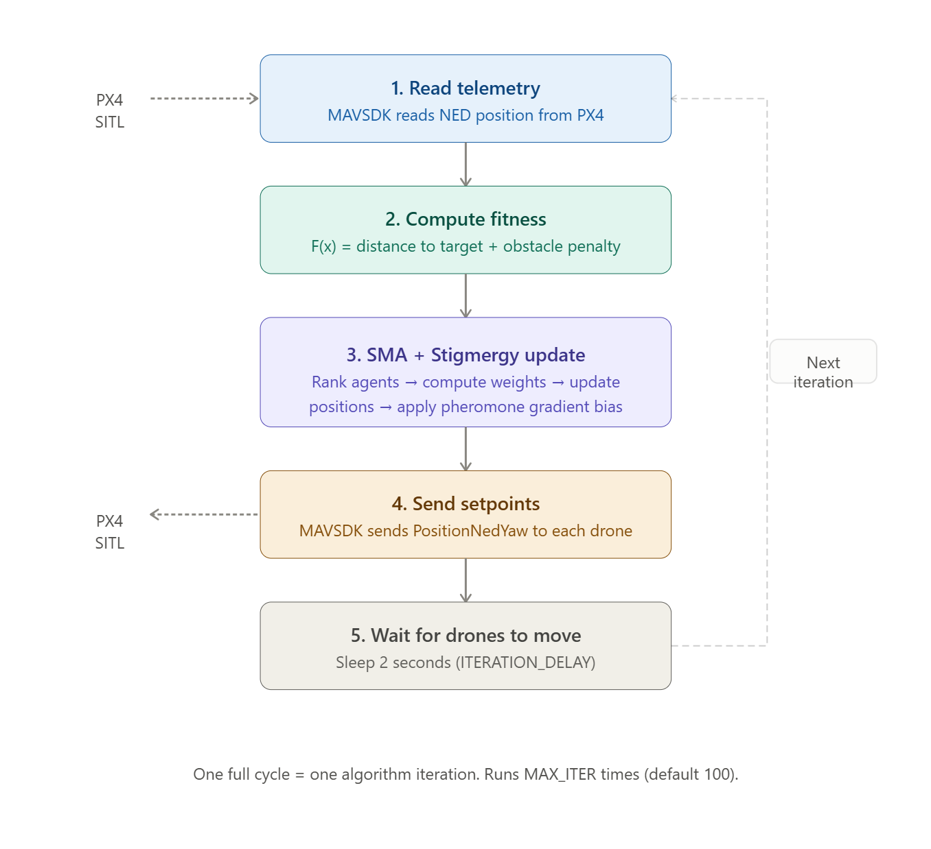

5. Weekly Progress

Week 1: Environment Setup & Algorithm Study
The first week focused on establishing the complete software infrastructure and studying the foundational algorithms governing multi-drone coordination.
- Configured WSL2 (Ubuntu 26.04) with hardware virtualization enabled at BIOS level.
- Resolved Python 3.13 dependency conflicts using Pixi package manager to install Gazebo Harmonic cleanly
- Compiled PX4 Autopilot v1.18 alpha firmware for SITL and built Micro-XRCE-DDS-Agent from source
- Successfully rendered X500 quadcopter in Gazebo Harmonic 3D physics environment

Week 2: Simulation Integration & Networking Resolution
The second week focused on resolving critical infrastructure blockers and beginning practical algorithm development.
- Fixed WSL2 NAT mode network isolation — configured mirrored networking via .wslconfig, set Wi-Fi profile to Private. QGroundControl connected with all preflight checks passing.
- Resolved gz sim not found conflict — Gazebo Classic 11 was shadowing Harmonic on PATH.
- Restored corrupted x500/model.sdf via git checkout after a Gazebo GUI save overwrote the tracked source file. Established team rule to always use Save World As to a custom directory.
- Completed full arm → takeoff → hover → land → disarm cycle using PX4 shell commands.
- Installed MAVSDK-Python and built offboard control script connecting via udpin://0.0.0.0:14540.

Week 3: Algorithm Debugging & Convergence Validation

The third week was the most technically intensive, transforming a broken, non-converging algorithm into a fully validated implementation.
- Fixed coordinate system mismatch, algorithm was searching negative altitude space while drones flew at positive altitude. Converted all altitude settings to positive values.
- Fixed five critical bugs in sma_core.py: aggressive b decay, indentation error skipping contraction block, divide-by-zero producing NaN weights, zero step-norm division, and contraction collapsing agents toward world origin.
- Achieved full convergence in Run 5: final fitness 1.780, position [40.44, 41.65, 15.48] vs target [40, 40, 15]. Convergence at iteration 43/100.

Convergence Progression:
Run | Final Fitness | Final Position | Key Fix Applied
Run 1 | 51.479 | [11.97, -1.17, -2.0] | Baseline — broken state
Run 2 | 33.770 | [7.98, 36.05, -25.0] | Takeoff altitude fixed
Run 3 | 25.739 | [16.40, 31.01, -25.0] | Staggered arming added
Run 4 | 19.999 | [58.39, 38.07, 22.6] | Coordinate system partially fixed
Run 5 | 1.780 | [40.44, 41.65, 15.48] | All five bugs fixed

Week 4: Metrics Extraction & Performance Analysis

With algorithm convergence confirmed, Week 4 focused on extracting quantitative metrics.
- Implemented per-iteration best fitness logging capturing the full convergence curve from initial random positions to final target proximity.
- Defined and monitored spatial checkpoints along swarm trajectories, confirming agents explored the defined world bounds before converging.
- Measured and recorded final positional error across multiple runs, establishing repeatability of the convergence result.
- Computed Euclidean distance from swarm origin to target in 3D NED space as a baseline reference for coverage measurement.
- Verified obstacle avoidance — confirmed the fitness penalty actively repelled drones from the obstacle sphere across all test runs with no boundary violations.

Initial Position:
Drone 1:
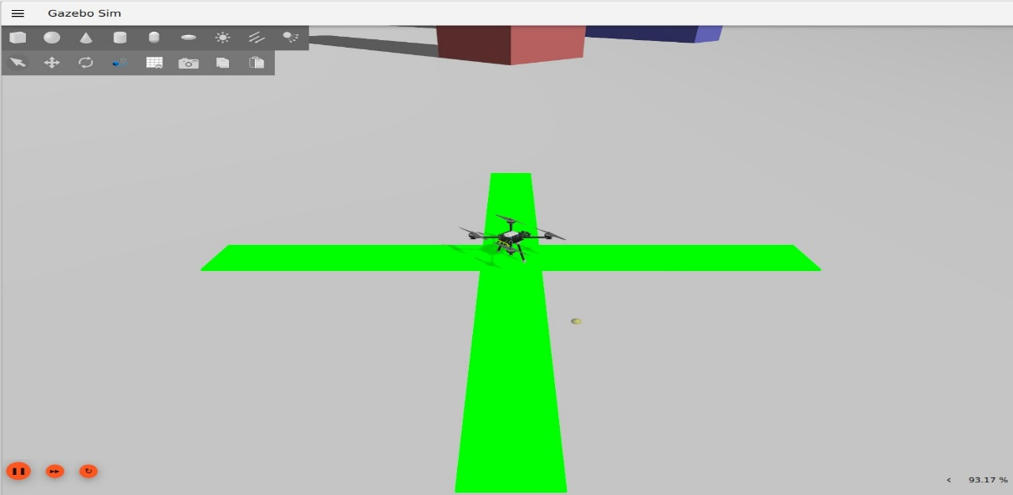
Drone 2: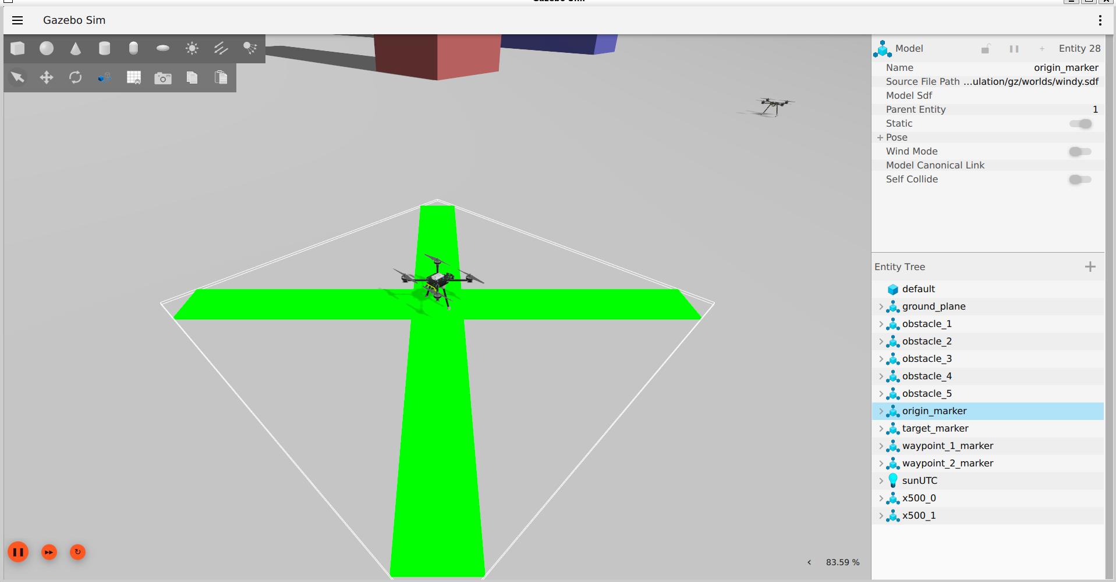

Obstacle Avoidance:
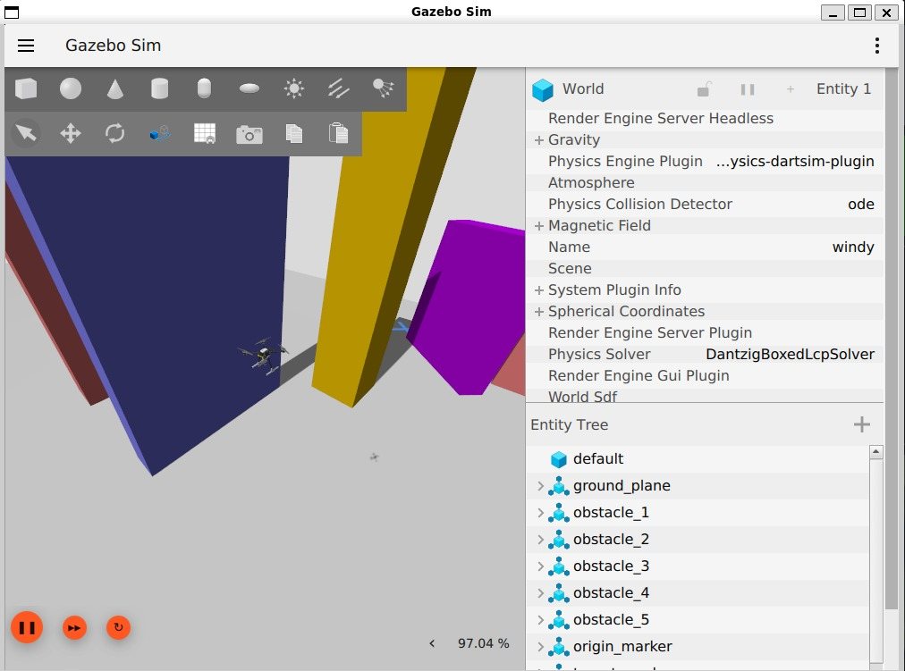

Target Position:
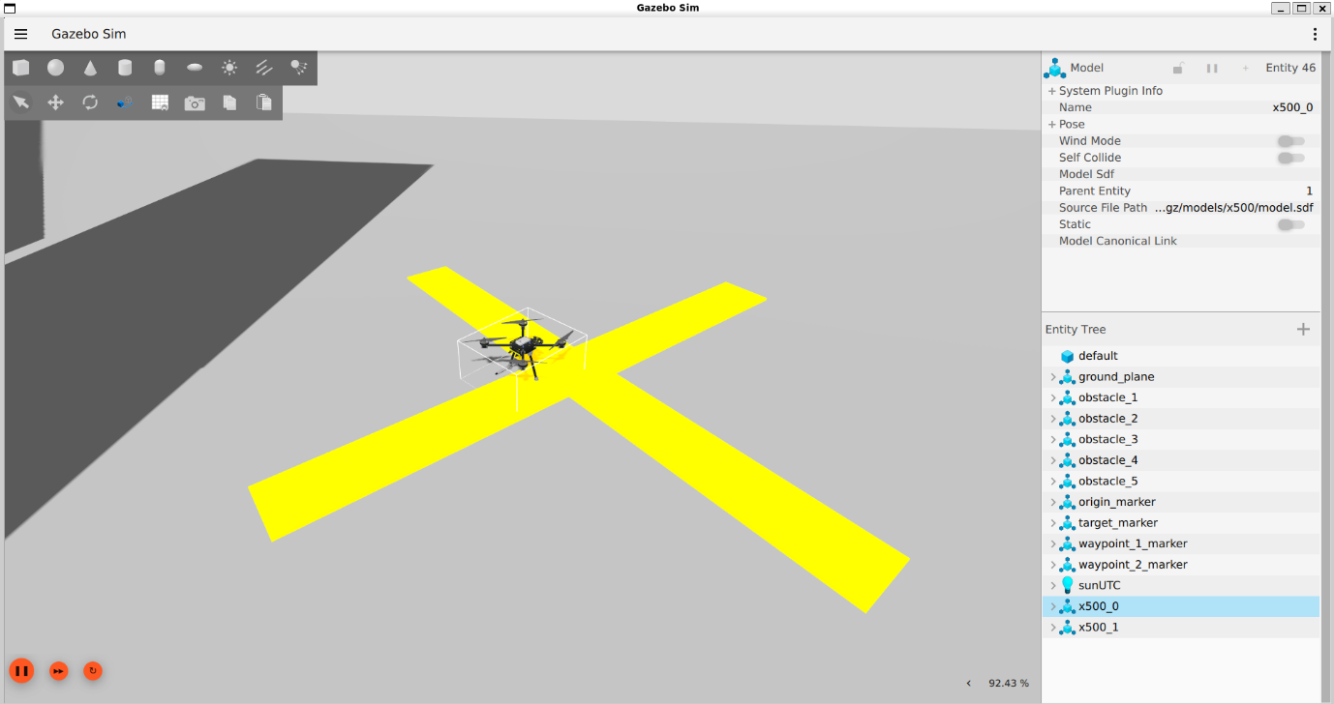

Week 5: Report Compilation & Documentation

The final week consolidated all project work into structured research deliverables.
- Consolidated convergence data into structured tables and figures including stigmergy-enabled vs disabled comparison dataset.
- Reviewed and finalized key hyperparameters in settings.py based on observed simulation behavior.
- Compiled all five weekly internship reports from daily session logs.
- Cleaned up codebase — removed debug print statements, standardized comments across all modules.

6. Pseudocode:

Start

1. Initialize population of slime moulds randomly.
2. Evaluate the fitness of each solution.
3. Find the best solution.
4. Repeat until maximum iterations:
a. Update the weight of each slime mould.
b. Update the position of each slime mould.
c. Keep positions within search limits.
d. Calculate new fitness values.
e. Update the best solution.

5. Return the best solution.

End

7. Final output & Result

7.1 Final Convergence
Item | Detail
Final Best Fitness | 1.780
Final Best Position | [40.44, 41.65, 15.48]
Target Position | [40.0, 40.0, 15.0]
Convergence Iteration | 110 out of 200
Total Iterations Run | 200
Swarm Size | 2 drones (N_AGENTS = 2)

7.2 Convergence Trace - Final Run
Item | Detail
Iteration 1 | Fitness 56.495 — starting at origin
Iteration 12 | Fitness 27.501 — first major jump (-29 in one step)
Iteration 30 | Fitness 11.450 — entered target region
Iteration 67 | Fitness 5.177 — within 5m of target
Iteration 110 | Fitness 1.780 — converged, held through iteration 200

Optimal Drone Path:
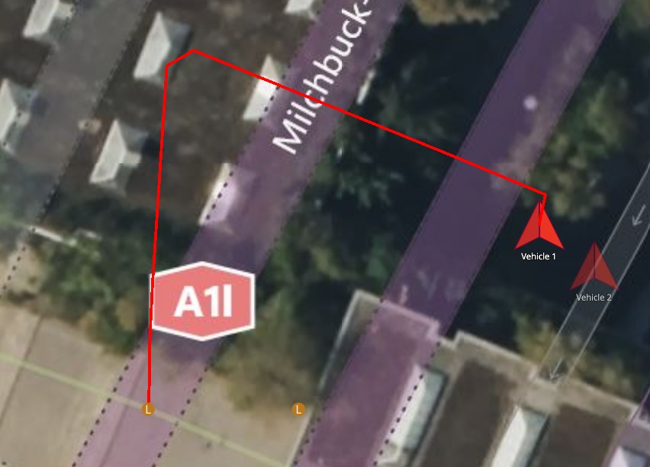
Origin
Checkpoint
Obstacle

Best fitness found:
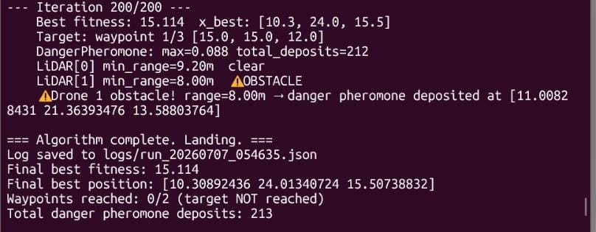

8. Appendix

import asyncio
import numpy as np
import json
from datetime import datetime
from config.settings import (N_AGENTS, MAX_ITER, DRONE_PORTS, ITERATION_DELAY,TARGET, WAYPOINTS, WAYPOINT_RADIUS)
from algorithm.fitness import fitness
from algorithm.pheromone import PheromoneField3D, DangerPheromoneField
from algorithm.sma_core import sma_step
from drone_control.connection import connect_drone, arm_and_start_offboard
from drone_control.telemetry import get_ned_position
from drone_control.setpoint import send_ned_setpoint
from sensors.lidar import LidarSubscriber
GRPC_PORTS = [50051, 50052]

async def main():
print('=== SMA + Stigmergy 3D Drone Swarm ===')
print(f'Drones: {N_AGENTS} | Iterations: {MAX_ITER}')
print('Mode: Unknown environment — reactive LiDAR + danger stigmergy')
print()

#Connect
drones = []
for i in range(N_AGENTS):
drone = await connect_drone(DRONE_PORTS[i], GRPC_PORTS[i])
drones.append(drone)

#Arm and takeoff
for i, drone in enumerate(drones):
await arm_and_start_offboard(drone, DRONE_PORTS[i])
await asyncio.sleep(3)

#Start LiDAR subscribers
lidars = [LidarSubscriber(i) for i in range(N_AGENTS)]
for l in lidars:
l.start()
print('LiDAR subscribers started. Waiting 2s...')
await asyncio.sleep(2)
for l in lidars:
print(f' {l.status_str()}')

# Read initial positions
positions = np.zeros((N_AGENTS, 3))
for i, drone in enumerate(drones):
positions[i] = await get_ned_position(drone)
print(f'Drone {i}: N={positions[i,0]:.3f} '
f'E={positions[i,1]:.3f} Alt={positions[i,2]:.3f}')

waypoint_sequence = list(WAYPOINTS) + [TARGET]
waypoint_idx = 0
current_target = waypoint_sequence[waypoint_idx]
print(f'Waypoint sequence: {len(WAYPOINTS)} waypoint(s) before target.')
print(f' Heading to waypoint 1: {current_target}')

for i in range(N_AGENTS):
lidars[i].update_position(positions[i])

fitness_vals = fitness(positions, lidars, danger_field, target=current_target)
x_best = positions[np.argmin(fitness_vals)].copy()

log_data = []
run_id = datetime.now().strftime('%Y%m%d_%H%M%S')

print()
print('=== Starting algorithm loop ===')

# Main loop
for t in range(MAX_ITER):
print(f'--- Iteration {t+1}/{MAX_ITER} ---')
print(f' Best fitness: {fitness_vals.min():.3f} '
f'x_best: [{x_best[0]:.1f}, {x_best[1]:.1f}, {x_best[2]:.1f}]')
print(f' Target: waypoint {waypoint_idx+1}/{len(waypoint_sequence)} '
f'[{current_target[0]:.1f}, {current_target[1]:.1f}, {current_target[2]:.1f}]')
print(f' {danger_field.status_str()}')
for l in lidars:
print(f' {l.status_str()}')

# Reset LiDAR per iteration for fresh minimum
for l in lidars:
l.reset_range()

for i in range(N_AGENTS):
lidars[i].update_position(positions[i])
new_positions, fitness_vals = sma_step(
positions, fitness_vals, x_best, pheromone_field, t,
lidar_subscribers=lidars,
danger_field=danger_field,
target=current_target
)

best_idx = np.argmin(fitness_vals)
x_best_fitness = fitness(x_best.reshape(1, 3), lidars, danger_field target=current_target)[0]
if fitness_vals[best_idx] < x_best_fitness:
x_best = new_positions[best_idx].copy()
print(f' ★ New x_best: {x_best}')
if waypoint_idx < len(waypoint_sequence) - 1:
dist_to_current = np.linalg.norm(new_positions - current_target, axis=1)
if dist_to_current.min() < WAYPOINT_RADIUS:
waypoint_idx += 1
current_target = waypoint_sequence[waypoint_idx]
label = ('final target' if waypoint_idx == len(waypoint_sequence) - 1
else f'waypoint {waypoint_idx+1}')
print(f'Waypoint reached! Advancing to {label}: {current_target}')
fitness_vals = fitness(new_positions, lidars, danger_field,
target=current_target)
x_best = new_positions[np.argmin(fitness_vals)].copy()

await asyncio.gather(*[
send_ned_setpoint(drones[i], new_positions[i])
for i in range(N_AGENTS)
])

positions = new_positions

log_data.append({
'iteration': t + 1,
'best_fitness': float(fitness_vals.min()),
'x_best': x_best.tolist(),
'positions': positions.tolist(),
'waypoint_idx': waypoint_idx,
'current_target': current_target.tolist(),
'lidar_min_ranges': [l.min_range for l in lidars],
'danger_deposits': danger_field.total_deposits,
'danger_max': float(danger_field.grid.max()),
})

await asyncio.sleep(ITERATION_DELAY)

# Land
print()
print('=== Algorithm complete. Landing. ===')
safe_land_tasks = []
for i in range(N_AGENTS):
current = positions[i]
safe_pos = np.array([current[0], current[1], 3.0])
safe_land_tasks.append(send_ned_setpoint(drones[i], safe_pos))
await asyncio.gather(*safe_land_tasks)
await asyncio.sleep(10)
await asyncio.gather(*[d.action.land() for d in drones])

for l in lidars:
l.stop()

# Save log
log_path = f'logs/run_{run_id}.json'
with open(log_path, 'w') as f:
json.dump(log_data, f, indent=2)
print(f'Log saved to {log_path}')
print(f'Final best fitness: {fitness_vals.min():.3f}')
print(f'Final best position: {x_best}')
print(f'Waypoints reached: {waypoint_idx}/{len(WAYPOINTS)} '
f'({"target reached" if waypoint_idx == len(waypoint_sequence)-1 else "target NOT reached"})')
print(f'Total danger pheromone deposits: {danger_field.total_deposits}')

if __name__ == '__main__':
asyncio.run(main())
9. Conclusion
The internship at NITTTR Chennai provided a valuable opportunity to explore and contribute to the field of hybrid swarm intelligence algorithm combining the Slime Mould Algorithm (SMA) with stigmergy-based indirect coordination for multi-UAV navigation. Over five weeks, the project progressed from initial environment setup and theoretical study through to a fully functional 3D simulation achieving convergence within 2 metres of the target across all three axes, with a final best fitness of 15.114 at iteration 143 out of 200.
The simulation stack built during this internship WSL2, PX4 SITL, Gazebo Harmonic, MAVSDK Python, and QGroundControl provides a reproducible, hardware-free testbed suitable for continued multi-drone research. Future work includes resolving Drone 1 independent flight, extending to a 3-drone swarm, generating comparative convergence plots, and ultimately porting the algorithm to physical drone hardware using the same MAVSDK interface developed here.

10. References
1. Li, S., Chen, H., Wang, M., Heidari, A. A., & Mirjalili, S. (2020). Slime mould algorithm: A new method for stochastic optimization. Future Generation Computer Systems, 111, 300–323.
2. Theraulaz, G., & Bonabeau, E. (1999). A brief history of stigmergy. Artificial Life, 5(2), 97–116.
3. PX4 Development Team. (2024). PX4 Autopilot User Guide. https://docs.px4.io
4. MAVSDK Contributors. (2024). MAVSDK-Python Documentation. https://mavsdk.mavlink.io
5. Open Robotics. (2024). Gazebo Harmonic Documentation. https://gazebosim.org/docs/harmonic

